FAKE NEWS DETECTION SYSTEM USING FEATURE BASED OPTIMISED MSVM CLASSIFICATION
Conclusion, Future Scope and References
Department of Computer Science and Engineering, [COLLEGE NAME]
Batch C6 (CSE-C) · Academic year [ACADEMIC YEAR]
Table 1: Project team
S.No. | Student name | Roll number
1 | Neela Mojes | 23K91A05H1
2 | Noor Saniya | 23K91A05H4
3 | Malkajgiri Akshitha | 23K91A05E2
4 | Maravajhala Radha Sri Aashritha | 23K91A05E7

Project guide: K Rajasekhar Rao
Chapter and section numbers quoted in the text (for example Chapter 8 or Section 6.2) refer to the full project report, 17.Final Document. Figures and tables in this document are numbered from 1.

1. CONCLUSION

1.1 Summary
The project set out to build a fake news detection system around a feature-based, optimised multi-class SVM: text features reduced by PCA, with the Firefly algorithm choosing features and parameters, and an explicit PARTIALLY TRUE class. The system was built and works end to end as a web application, a command-line tool and a Streamlit app over one library. It accepts a statement or a CSV, returns a verdict with a confidence, class probabilities and cue words, shows its own statistics and can be retrained on a user's labelled data.
The report measured the system honestly. The model shipped with the project was trained on a synthetic template corpus and scores 1.000 on its own hold-out, but only 0.155 macro-F1 on real statements. A model trained on 3,000 real LIAR2 statements reaches a macro-F1 of 0.429 ± 0.010 and an accuracy of 0.494 ± 0.008 on the 2,296 test statements, over three seeds.

1.2 Objectives achieved
• Achieved: a labelled dataset was obtained and mapped to three classes (objective 1, for evaluation); PCA reduces 4,025 features to at most 300 components (3); the Firefly algorithm is implemented and selects components and SVM parameters (4, implemented); an RBF multi-class SVM is trained on the selected features (5); accuracy, precision, recall and F1 are evaluated against unoptimised baselines (6).
• Partly achieved: preprocessing (2) covers cleaning, stop-word removal and vectorisation but not stemming.
• Not achieved: the aim of improving accuracy and computational cost. The optimised pipeline is not better than a default SVM or random search on the test split, and it is about 1475 times slower to train than a linear SVM that scores better.

1.3 Key findings
1. On real, short, fact-checked statements the three-class task is hard: macro-F1 is about 0.43, and the best simple model (logistic regression on all training statements) reaches 0.50.
2. The Firefly search improves its own training fitness over random search (0.433 against 0.426) but not the test score; on this data the optimiser does not pay for its cost of about 504 s per fit.
3. FAKE is recognised best (F1 0.63) and PARTIALLY TRUE worst (0.24); half-truths cannot be told apart by vocabulary and style.
4. Confidence is informative: accuracy rises from 0.37 for confidence between 0.4 and 0.5 to 0.79 between 0.7 and 0.8; but the verdict and the displayed probabilities disagree on 49 % of the statements.
5. A perfect score on a synthetic corpus says nothing about real text, and the PCA step keeps only 29 % of the variance on real text because of its cap.
6. The software is sound: 83 automated checks pass, a statement is classified in about 4 ms and 2,296 statements in about 1.2 s.

1.4 Practical applications
• A teaching and demonstration tool for a complete classical machine-learning pipeline (features, PCA, metaheuristic tuning, SVM) with a working interface and honest analytics.
• A screening aid that flags writing in a sensational or one-sided style for a human to look at, and a baseline for comparison with heavier models.
• A starting point for retraining on a newsroom's or a class's own labelled data through the Retrain screen.
• It is not suitable for deciding whether a claim is true, nor for moderation or legal decisions.

1.5 Known limitations
The main limitations are the synthetic shipped model (L1), the absence of any fact-checking (L2), the missing gain from the optimiser (L3), the weak PARTIALLY TRUE class (L4), the capped PCA (L5), the mismatch between verdict and probabilities (L6) and the small training subsample with few seeds (L7). The full list L1 to L13 is given in the document on scope and limitations.
The comparison with the simpler models and the accuracy by confidence bin behind the key findings are shown below.
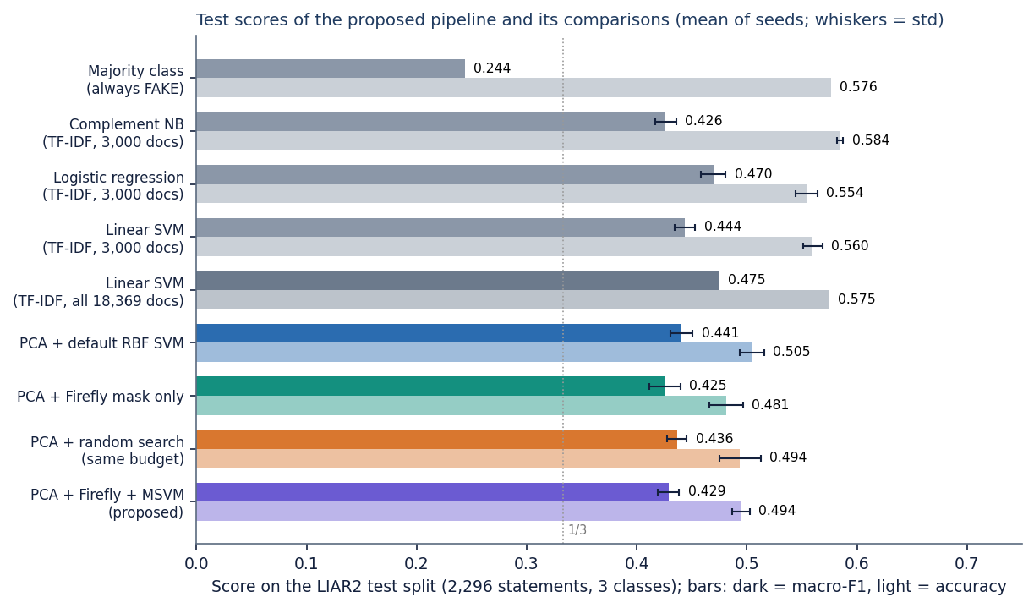
Figure 1: Test scores of the proposed pipeline and its comparisons on the LIAR2 test split.
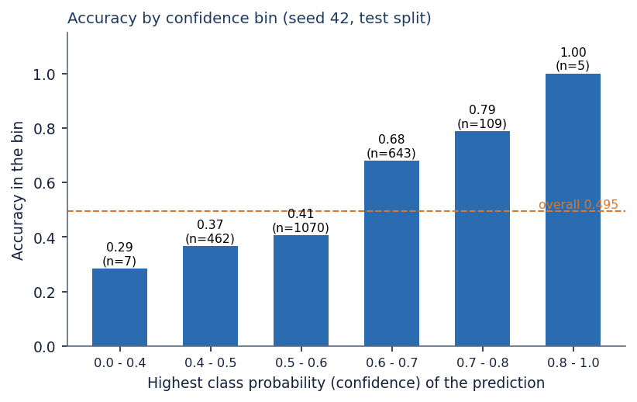
Figure 2: Accuracy of the verdict by confidence bin (seed 42, test split).

2. FUTURE SCOPE

2.1 Improvements to the model
1. Make the verdict and the probabilities consistent (untested): calibrate the probabilities with class priors taken into account, or derive both from the decision function, and show the calibrated confidence. This removes the mismatch of L6.
2. Remove the PCA cap or use incremental or truncated PCA on the sparse matrix without standardising it (untested), and measure the variance kept and the effect on the score (L5).
3. Train the pipeline on all 18,369 LIAR2 training statements, for example with a cheaper fitness (a subsample inside each fold) or a surrogate, and report the result with confidence intervals over more seeds (L7).
4. Tune the Firefly parameters (population, generations, alpha, beta0, gamma, penalty) and compare with Bayesian optimisation, as in the related work [3] (untested).
5. Add the missing preprocessing (stemming or lemmatisation) and measure each feature block separately (L9).
6. Try contextual embeddings as features, which the base paper found to add about three points of accuracy over TF-IDF [1] (untested here), possibly followed by the same PCA and Firefly steps to keep the classifier light.
7. Treat PARTIALLY TRUE as an ordinal rather than a nominal class, using the six original labels (for example ordinal regression), because the errors follow the truthfulness scale (Chapter 8).

2.2 Improvements to the application
• Show the verdict, the calibrated probabilities and a warning when the confidence is below a chosen level.
• Replace the fixed wording about the demo corpus by text read from the loaded model (L10), and fix the true/false label parsing in load_csv (L11).
• Explain a verdict by listing the TF-IDF terms and stylometric features that contributed most, in the spirit of LIME and SHAP used by the base paper.
• Support more languages by language-specific stop-word and cue lists.
• Export and import of models with version information, and keep a history of retraining runs.

2.3 Scalability and deployment
• Serve the backend with several worker processes behind a reverse proxy, add authentication and rate limits, and store models and retraining jobs outside the process (L12).
• Move retraining to a job queue so that long Firefly searches do not share the machine with the API.
• Run a load test and measure memory use; the model files are 0.85 MB (demo) and 12.6 MB (LIAR2, 3,000 documents) and load in a few seconds.
• Package the application as a container image for one-command deployment.

2.4 Further research
• Evaluate on several datasets and across datasets (ISOT, LIAR-PLUS, article-level corpora) and measure the transfer from one to another.
• Combine the text classifier with evidence retrieval so that a claim is checked against sources, which is what the present approach cannot do (L2).
• Study which metaheuristics help text classification at all, with equal budgets and many seeds, since this report found no gain for one of them.
• Run a user study on whether readers understand and trust a three-level verdict with a confidence.

3. REFERENCES
[1] M. Saad, S. Abdelrazek and I. R. Abdelmaksoud, "An algorithmic system for Arabic fake news detection using neural networks and transformer embeddings with class weighting," Scientific Reports, vol. 16, Art. no. 12226, 2026, doi: 10.1038/s41598-026-45653-4.
[2] P. Dell'Oglio, A. Bondielli, F. Marcelloni and L. C. Passaro, "An experimental comparison of the most popular approaches to fake news detection," Information Sciences, 2026, doi: 10.1016/j.ins.2026.123407; arXiv:2603.25501.
[3] T. Huang, Z. Xu, P. Yu, J. Yi and X. Xu, "A hybrid transformer model for fake news detection: Leveraging Bayesian optimization and bidirectional recurrent unit," 2025, arXiv:2502.09097.
[4] C. Xu and M.-T. Kechadi, "An enhanced fake news detection system with fuzzy deep learning," IEEE Access, vol. 12, pp. 88006-88021, 2024, doi: 10.1109/ACCESS.2024.3418340.
[5] W. Y. Wang, "'Liar, liar pants on fire': A new benchmark dataset for fake news detection," in Proc. 55th Annu. Meeting Assoc. Comput. Linguistics (ACL), Vol. 2: Short Papers, Vancouver, Canada, 2017, pp. 422-426, doi: 10.18653/v1/P17-2067.
[6] X.-S. Yang, "Firefly algorithms for multimodal optimization," in Stochastic Algorithms: Foundations and Applications (SAGA 2009), Lecture Notes in Computer Science, vol. 5792. Berlin, Germany: Springer, 2009, pp. 169-178.
[7] X.-S. Yang, "Firefly algorithm, stochastic test functions and design optimisation," Int. J. Bio-Inspired Computation, vol. 2, no. 2, pp. 78-84, 2010.
[8] C. Cortes and V. Vapnik, "Support-vector networks," Machine Learning, vol. 20, no. 3, pp. 273-297, Sep. 1995.
[9] C.-W. Hsu and C.-J. Lin, "A comparison of methods for multiclass support vector machines," IEEE Trans. Neural Netw., vol. 13, no. 2, pp. 415-425, Mar. 2002.
[10] I. T. Jolliffe and J. Cadima, "Principal component analysis: a review and recent developments," Phil. Trans. R. Soc. A, vol. 374, no. 2065, Art. no. 20150202, 2016.
[11] S. Wold, K. Esbensen and P. Geladi, "Principal component analysis," Chemometrics and Intelligent Laboratory Systems, vol. 2, nos. 1-3, pp. 37-52, 1987.
[12] J. C. Platt, "Probabilistic outputs for support vector machines and comparisons to regularized likelihood methods," in Advances in Large Margin Classifiers. Cambridge, MA, USA: MIT Press, 1999, pp. 61-74.
[13] G. Salton and C. Buckley, "Term-weighting approaches in automatic text retrieval," Information Processing & Management, vol. 24, no. 5, pp. 513-523, 1988.
[14] F. Pedregosa et al., "Scikit-learn: Machine learning in Python," J. Mach. Learn. Res., vol. 12, pp. 2825-2830, 2011.
[15] H. He and E. A. Garcia, "Learning from imbalanced data," IEEE Trans. Knowl. Data Eng., vol. 21, no. 9, pp. 1263-1284, Sep. 2009.
[16] K. Shu, A. Sliva, S. Wang, J. Tang and H. Liu, "Fake news detection on social media: A data mining perspective," ACM SIGKDD Explorations Newsletter, vol. 19, no. 1, pp. 22-36, 2017.
[17] S. Vosoughi, D. Roy and S. Aral, "The spread of true and false news online," Science, vol. 359, no. 6380, pp. 1146-1151, Mar. 2018.
[18] X. Zhou and R. Zafarani, "A survey of fake news: Fundamental theories, detection methods, and opportunities," ACM Comput. Surv., vol. 53, no. 5, Art. no. 109, 2020; arXiv:1812.00315.
[19] H. Ahmed, I. Traore and S. Saad, "Detection of online fake news using N-gram analysis and machine learning techniques," in Intelligent, Secure, and Dependable Systems in Distributed and Cloud Environments (ISDDC 2017), Lecture Notes in Computer Science, vol. 10618. Cham, Switzerland: Springer, 2017, pp. 127-138.
[20] V. Perez-Rosas, B. Kleinberg, A. Lefevre and R. Mihalcea, "Automatic detection of fake news," in Proc. 27th Int. Conf. Comput. Linguistics (COLING), Santa Fe, NM, USA, 2018, pp. 3391-3401.
[21] M. Potthast, J. Kiesel, K. Reinartz, J. Bevendorff and B. Stein, "A stylometric inquiry into hyperpartisan and fake news," in Proc. 56th Annu. Meeting Assoc. Comput. Linguistics (ACL), Melbourne, Australia, 2018, pp. 231-240.
[22] H. Rashkin, E. Choi, J. Y. Jang, S. Volkova and Y. Choi, "Truth of varying shades: Analyzing language in fake news and political fact-checking," in Proc. Conf. Empirical Methods in Natural Language Processing (EMNLP), Copenhagen, Denmark, 2017, pp. 2931-2937.
[23] J. Devlin, M.-W. Chang, K. Lee and K. Toutanova, "BERT: Pre-training of deep bidirectional transformers for language understanding," in Proc. NAACL-HLT, Minneapolis, MN, USA, 2019, pp. 4171-4186.
[24] B. Xue, M. Zhang, W. N. Browne and X. Yao, "A survey on evolutionary computation approaches to feature selection," IEEE Trans. Evol. Comput., vol. 20, no. 4, pp. 606-626, Aug. 2016.
[25] L. Zhang, K. Mistry, C. P. Lim and S. C. Neoh, "Feature selection using firefly optimization for classification and regression models," Decision Support Systems, vol. 106, pp. 64-85, 2018.
[26] Y. Al-Tarawneh, H. Kanj and W. Aly, "Enhancing fake news detection with word embedding: A machine learning and deep learning approach," Computers, vol. 13, no. 9, Art. no. 239, 2024.
[27] "Word embedding and classification methods and their effects on fake news detection," 2024. [Listed in the batch literature survey; authors and venue not verified.]
[28] "A deep learning ensemble framework for fake news stance detection and classification," Nanotechnology Perceptions, 2024. [Listed in the batch literature survey; authors not verified.]
[29] "Fake news detection using machine learning techniques," 2025. [Listed in the batch literature survey; authors and venue not verified.]
[30] "Analysis of fake news detection and prevention of various fake news detection algorithms and their research challenges," in Text and Social Media Analytics for Fake News and Hate Speech Detection, 2024. [Listed in the batch literature survey; authors not verified.]

